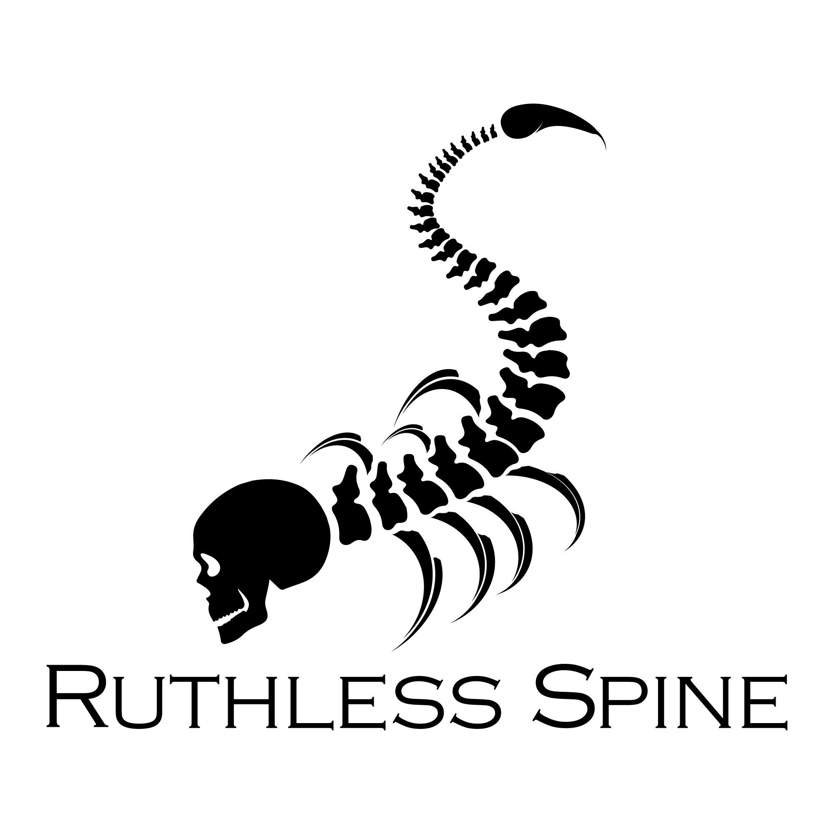

|  |  |  |
| --- | --- | --- |
| Level | Left | Right |
| L1 |  |  |
| L2 |  |  |
| L3 |  |  |
| L4 |  |  |
| L5 |  |  |
| S1 |  |  |